**WEEK 3**

**INSTALLATION OF DEV C++**

**Steps:**

* We can get the appropriate installation file for Dev C++ from <https://www.bloodshed.net/>

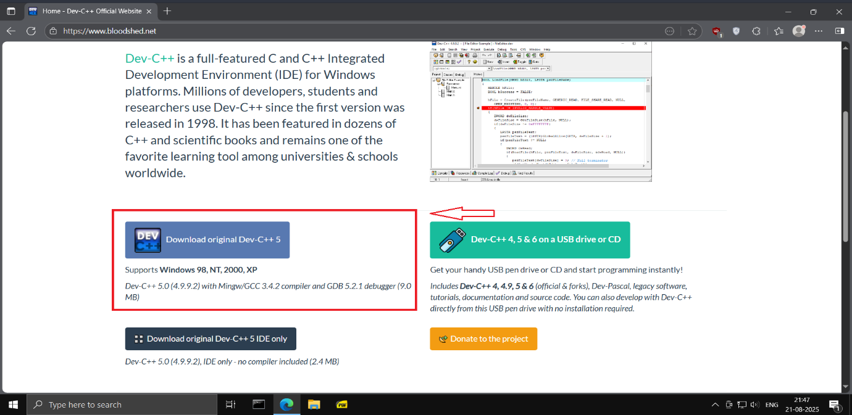

* Click on download.

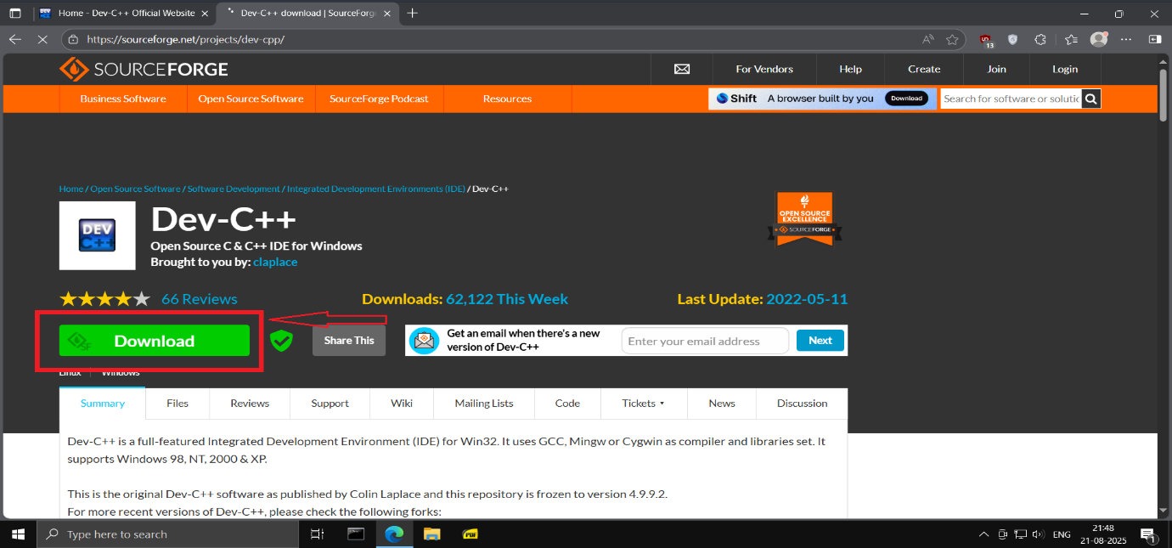

* Execute the downloaded exe files to start the installation process.

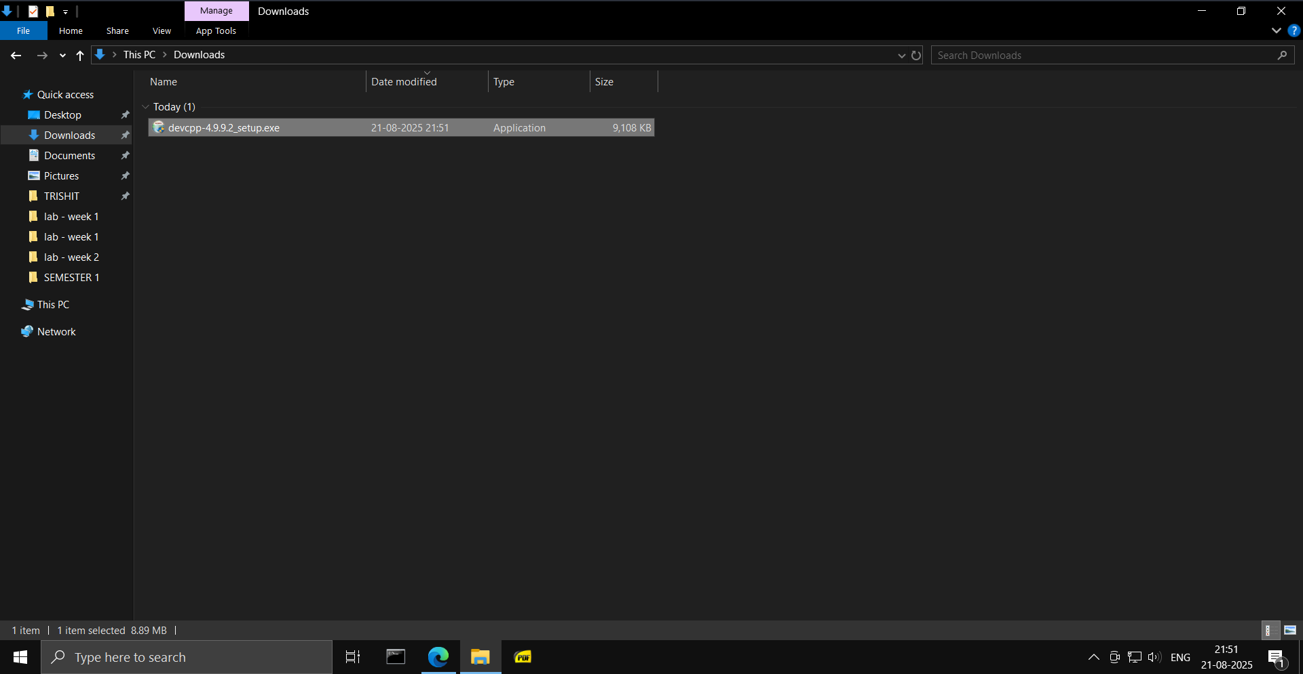

* Select the language, click on I Agree license and install the rest of the component that come through.

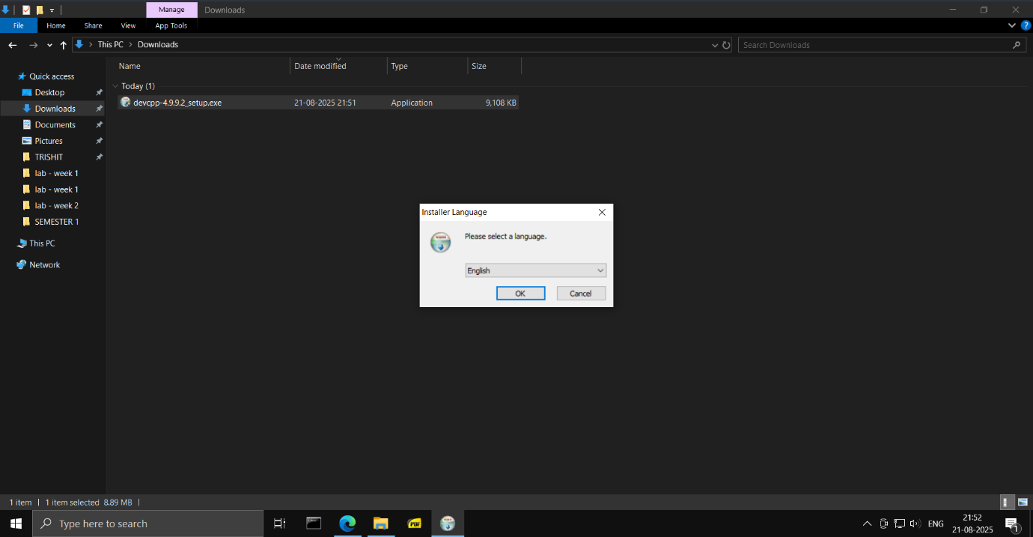

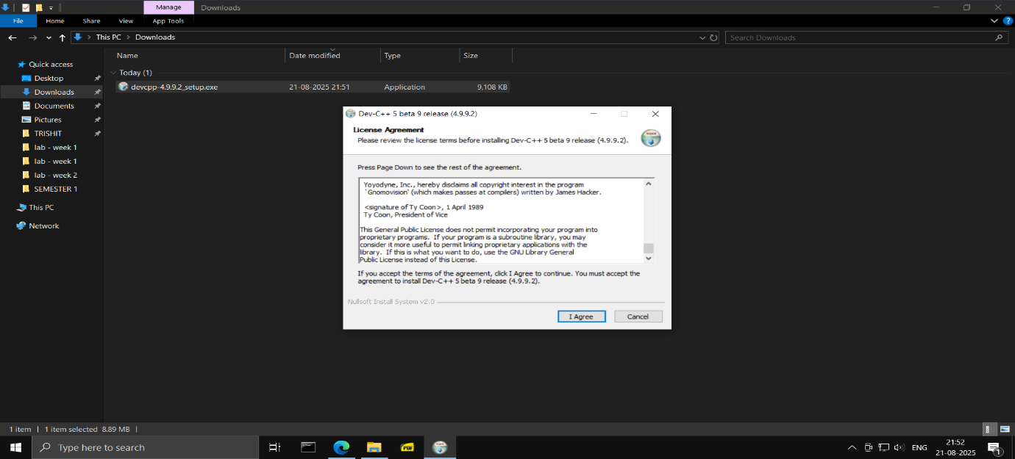

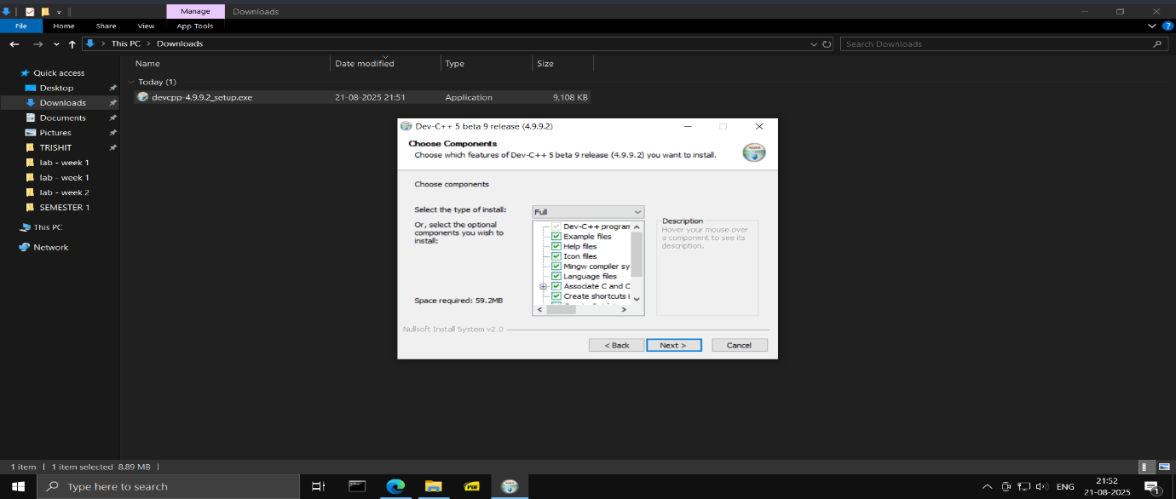

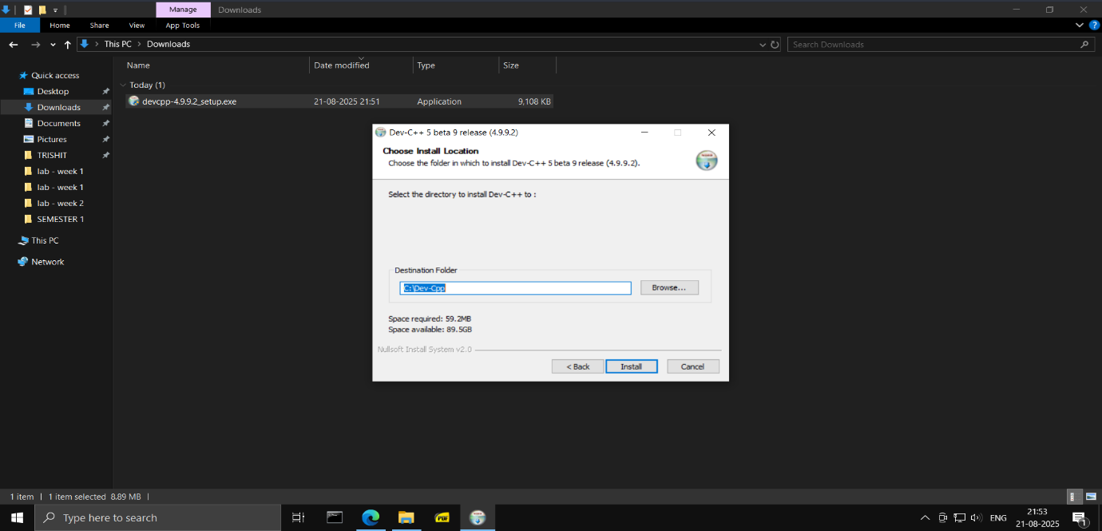

* The following screenshot shows the progress of the installation.

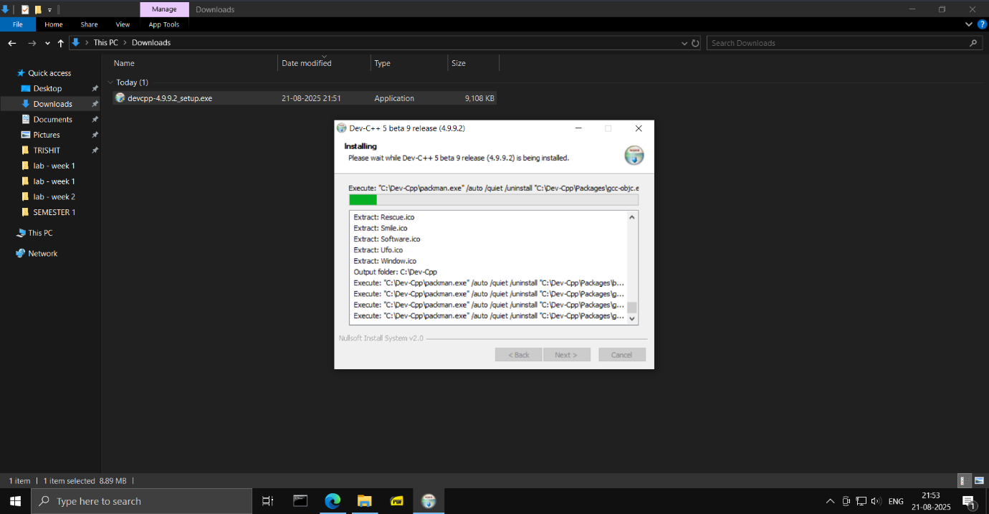

* Dev-C++ has been installed. This is the result.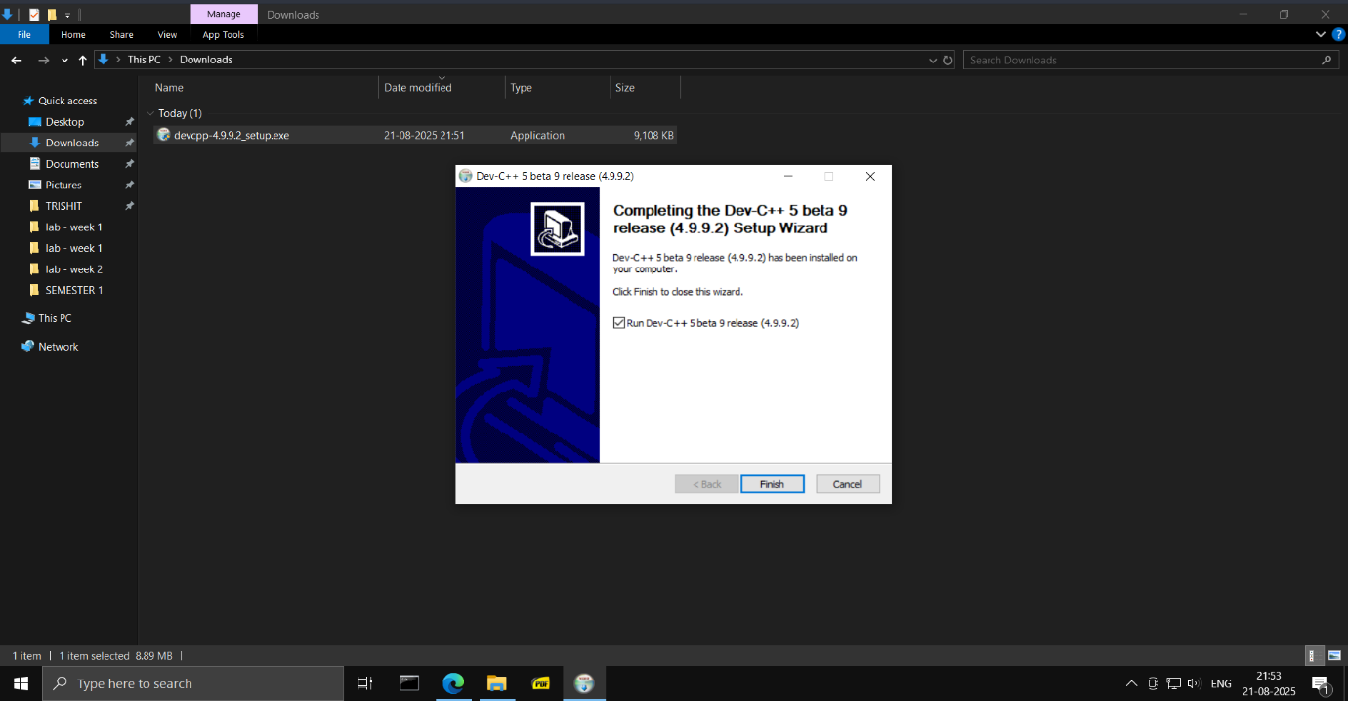
* Change Linker setting for Debugging.

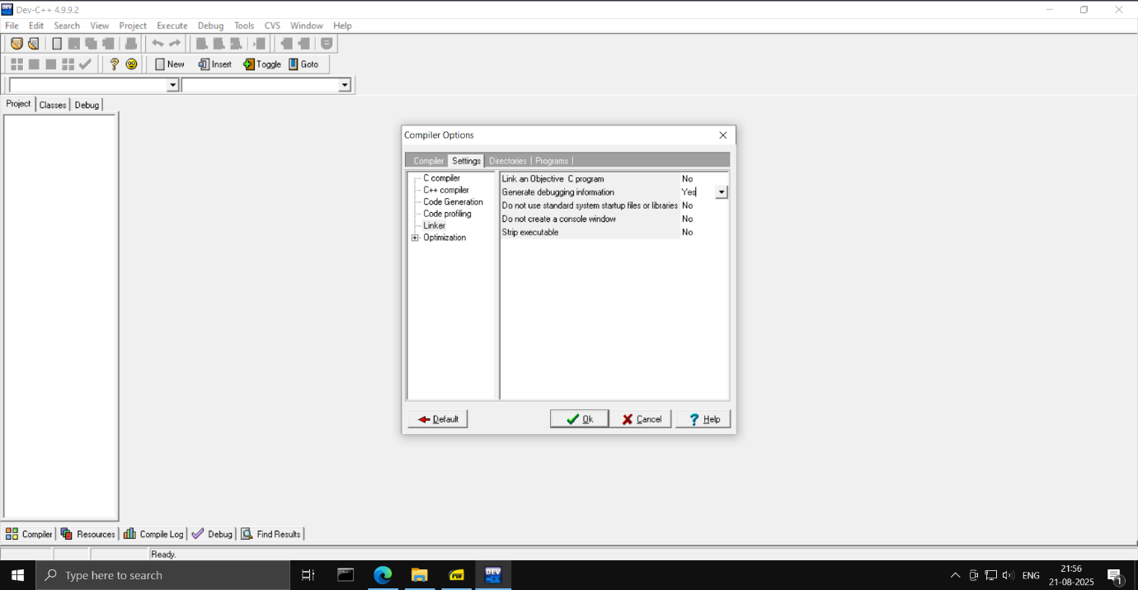

* Create a new empty project with the language as C++ selected.

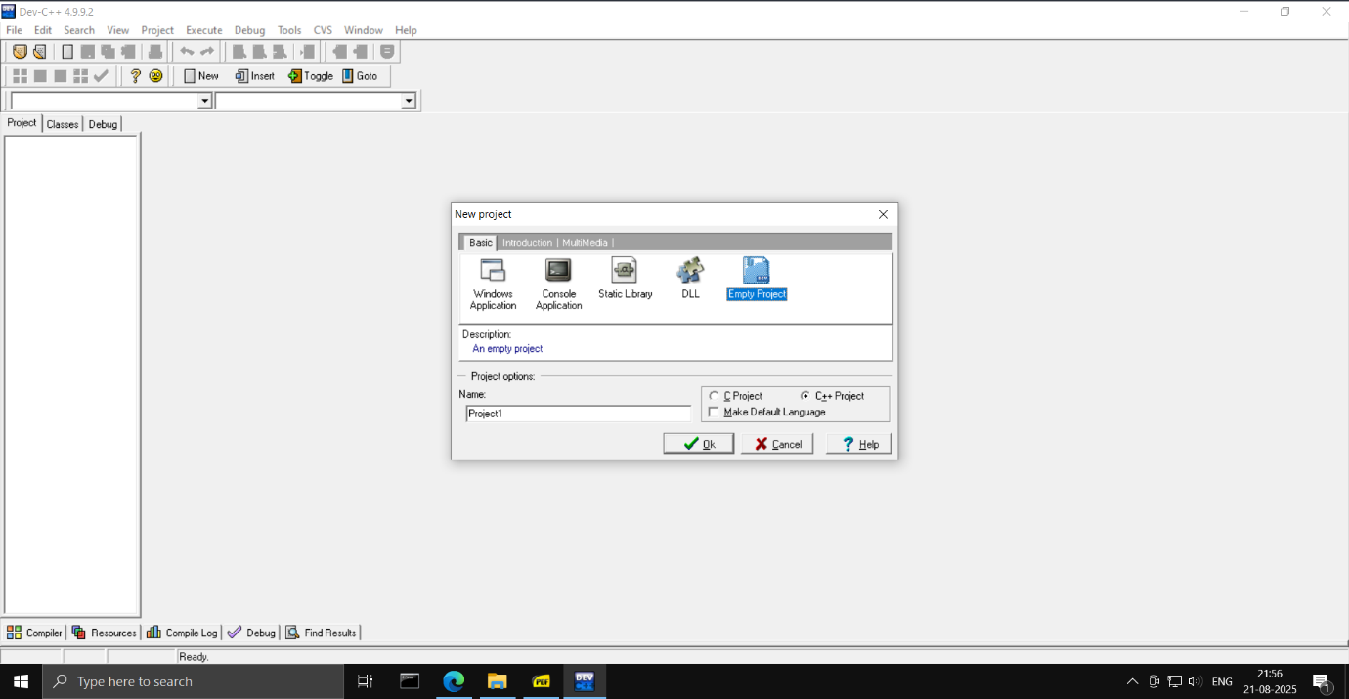

* Here is a simple basic program.

